In the lecture we looked at the use of arrays in Java.

Exercises
To practise arrays (and recap methods of input too).

- Write a program called Multiples which will use an array to store all the multiples of 5 up to 60 (i.e. the answers to the 5-times table). To do this you will either need an array of length 13 (with an element for 0x5 or you will need to play around with the loop indexes). Using a message dialog box, use it to print out the answer to 7x5

- Adapt this for a new program called MultiplesInput to allow the user to choose the table (e.g the 6-times table) stored and the multiple wanted (e.g. 9) using JOptionPane.
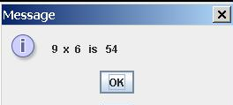
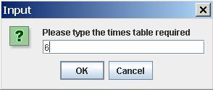
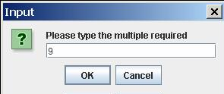

- This time make a version called MultiplicationTables where you construct all the answers to all the times tables up to 12 using a 13 x 13 2D array (once again, you need element for the 0-times table). You may need help in filling this in but try and work it out for yourself. Make a version based on question 2 which allows you to input the numbers to be multiplied with dialog boxes.

- Separate MultiplicationTables into a GUI (as below) and an auxiliary class, called MultiplicationTables GUI and MultiplicationTablesData respectively. The auxiliary should create the multiplication tables when it is instantiated and then when the “Answer” button is pressed, the GUI should pass the two numbers across to the auxiliary and receive the answer back. (This rather an overkill to program what is just a multiplication but it is very good practice in using arrays, passing parameters together with auxiliary classes and their methods).

